Hexaflexagon Instructions
Materials:
- Paper
- Scissors
- Gluestick
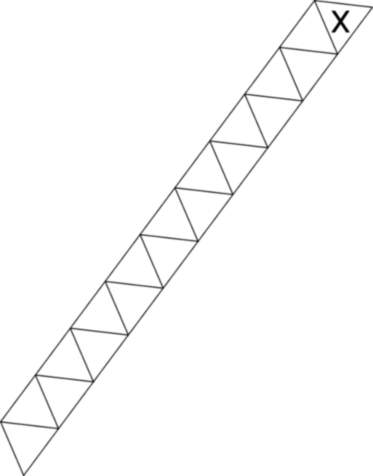
Directions:
- Cut out a strip of paper about 3/4 inch wide and 11¹/₂ inch long (strip off a sheet of standard copy/printer paper.)
- Fold equilateral triangles down the length of the strip so that it looks like the template at the right. You can do this by folding the top corner down and across to the opposite edge, or by choosing a point along the edge and folding the edge into 60 degree angles. Make sure you fold the triangles away from each other, so that you end up with a slinky shape rather that a strip curved into itself. As this is very confusing to verbally understand, you may want to just print out the template! *****
- After you have your template, number the triangles as shown:

front

back
Notice that the two blank sides (for glue) are on opposite ends.
- With the front side facing you, fold the first 3 behind the first 2, and keep folding in that way until you have a twisty spirally loop with all 1's, 2's, and 3's on the outside and with the numbering: 1 2 2 3 3 1 1 2 2 3
- Fold the paper into a hexagon shape so that all triangles with the same number are on the same side. ex all 2's on one side and 3's on the other.
- Apply glue to the two "glue" triangles and stick them together to complete the hexaflexagon.
How to flex a hexaflexagon:
Since hexagons have three way symmetry, fold the hexaflexagon into a three pointed star and open the inside out. (see diagram below)
